INFORMATION MANAGEMENT
Nikhil Ramasani
VU Student Id: 4070579
Module 12: Database Industry Careers
Exercise-8
1) Using scripting language, connect to the performance_schema. Show all tables in the performance_schema then show the attributes and records as shown in the table USERS.
Answer
Query:
use performance_schema;
show tables;
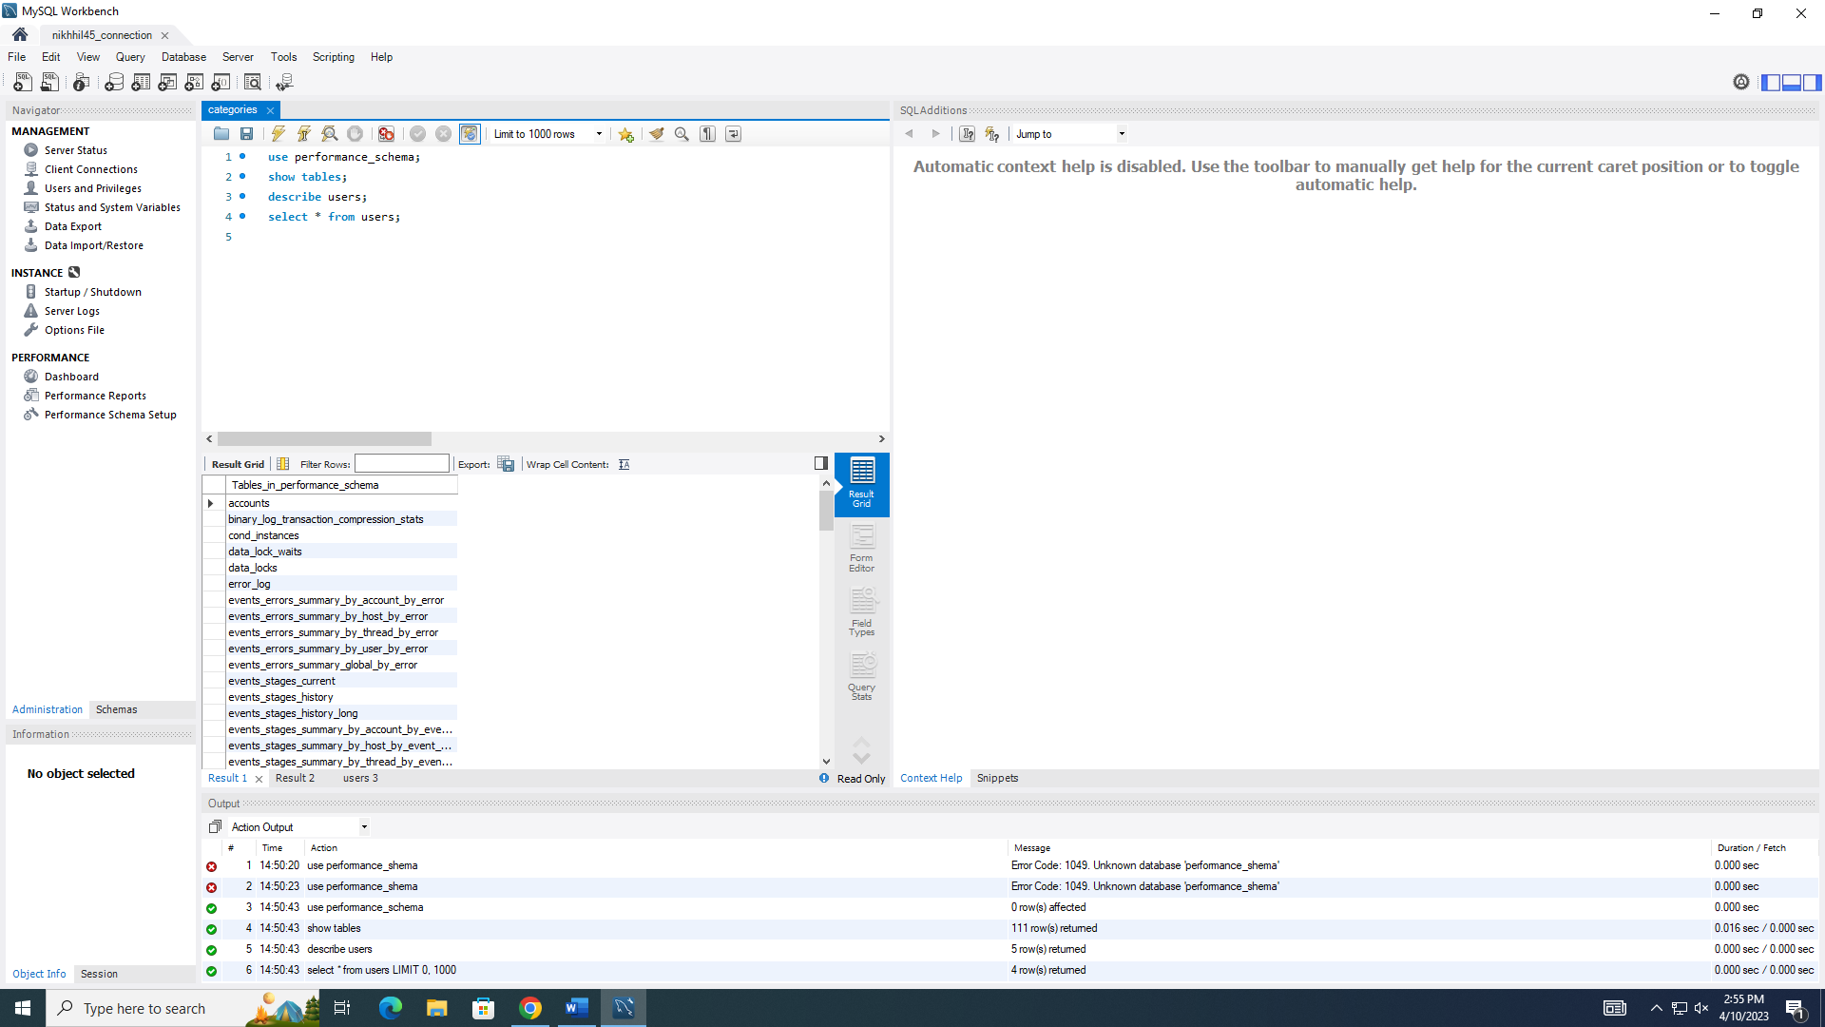

Query:
use performance_schema;
show tables;
describe users;

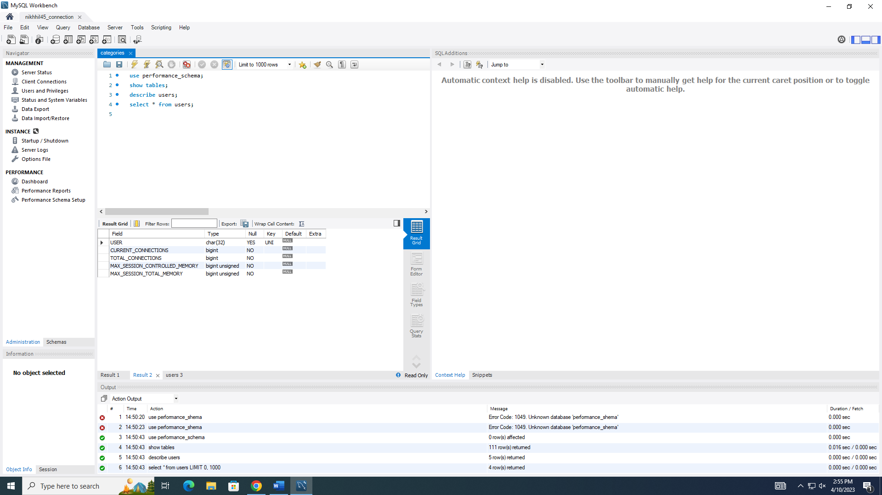

Query:
use performance_schema;
show tables;
describe users;
select * from users;

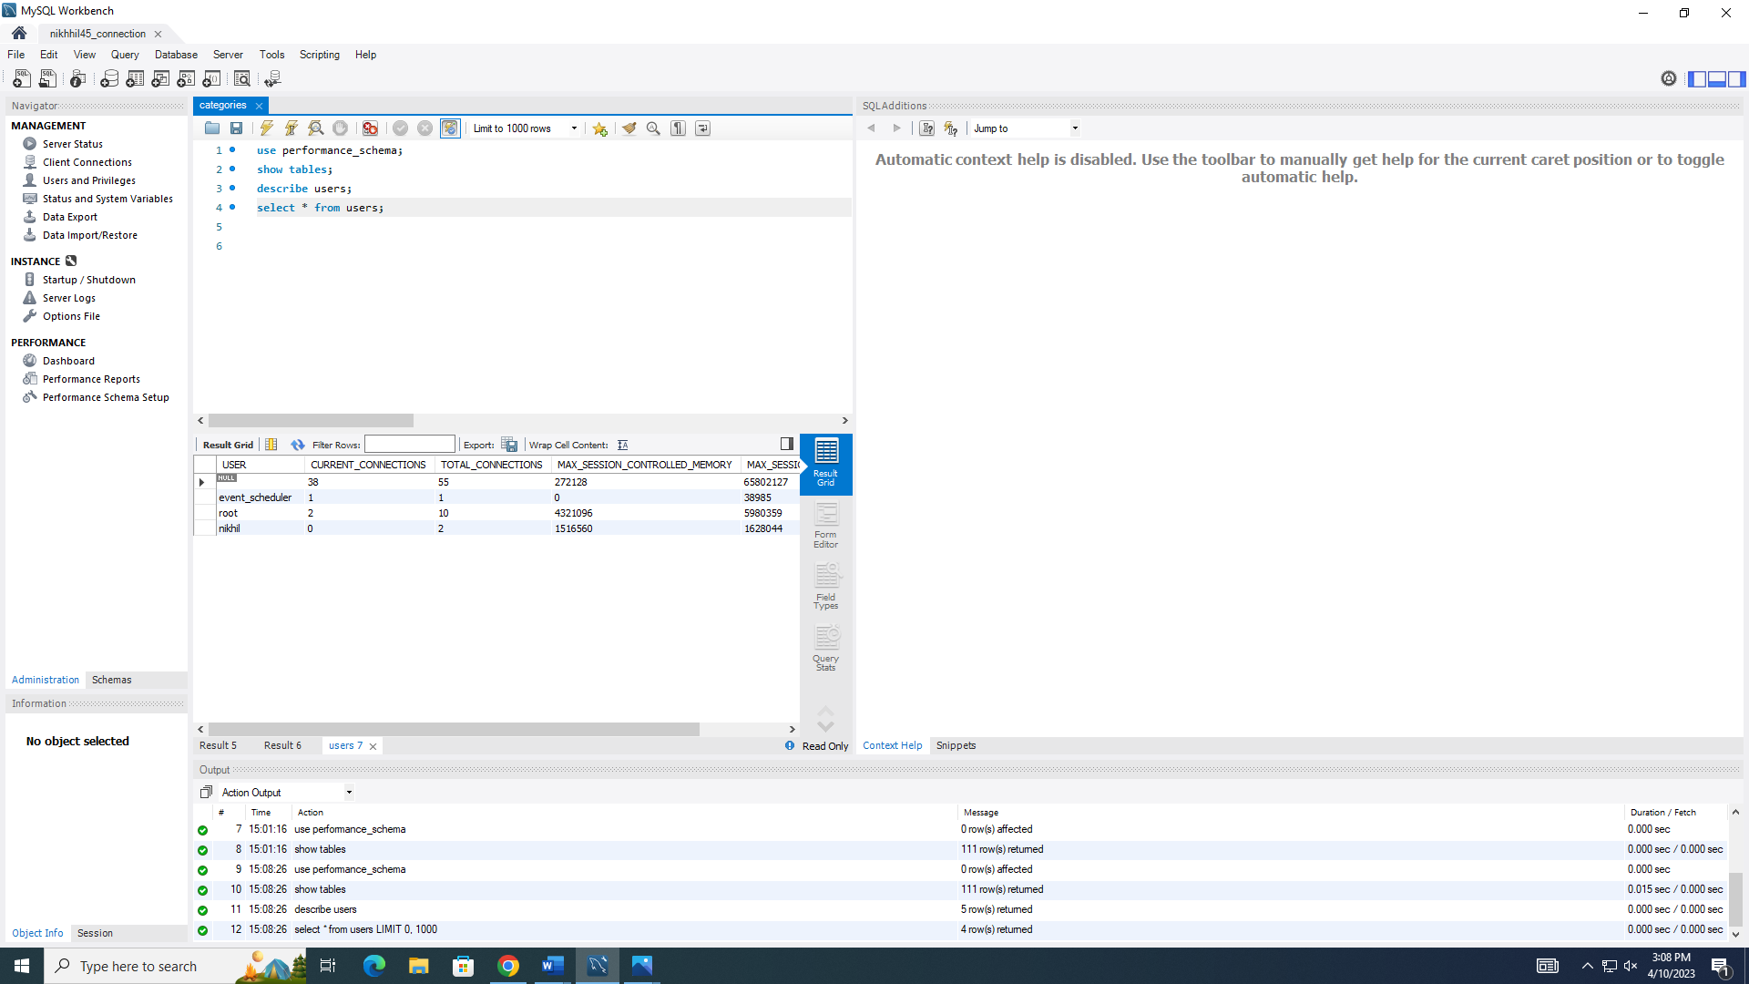
2) Using the performance schema and scripting language, show all attributes and records as shown in the table status_by_account for one of the new users you created in exercise 7 exercise.
Answer
Query:
use performance_schema;
show tables;
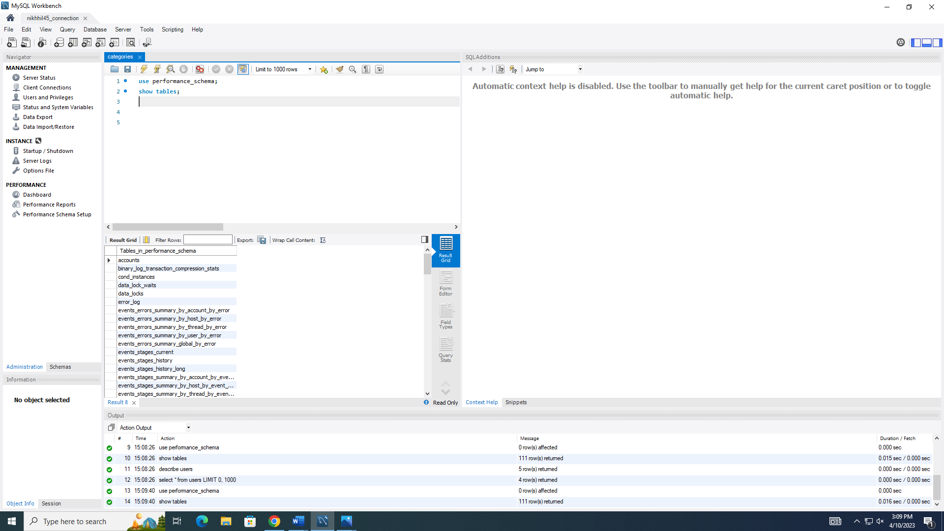

Query:
use performance_schema;
show tables;
select * from status_by_account where user = 'root';

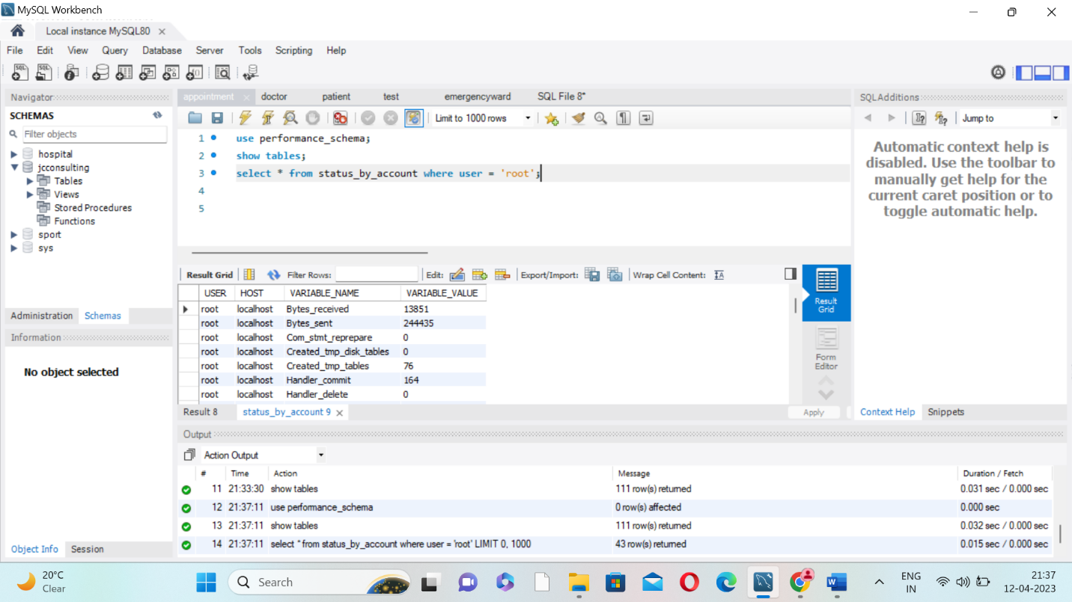

3) Using the Workbench Navigator panel, use the Management area to view Status and System Variables to determine the performance schema system variable that indicates the maximum number of bytes stored from SQL statements. Provide a screenshot to show your findings.
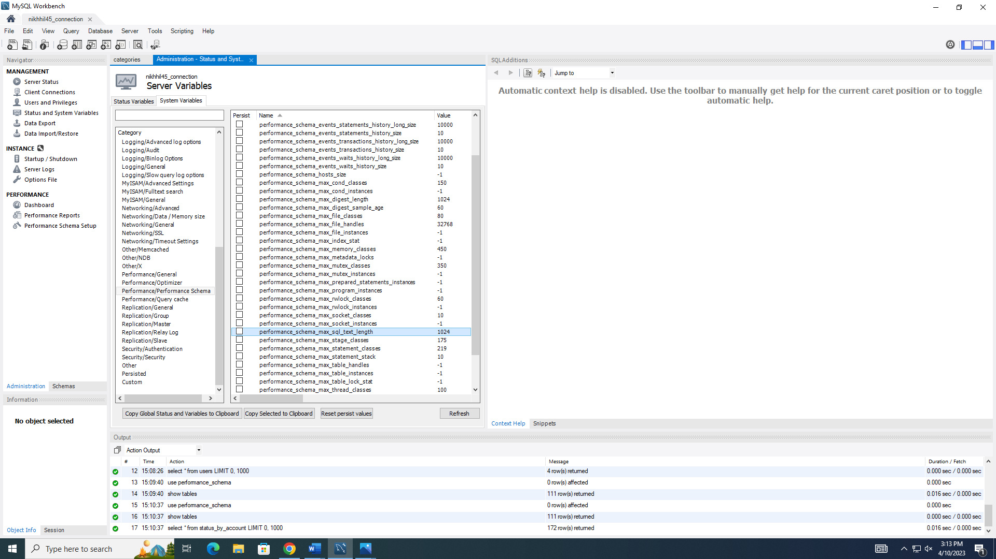

4) Using the Workbench Navigator panel, use the Performance Report area to determine the highest cost SQL statements in the highest 5 percent by runtime; sort your list by Average Time (us) in descending order (high to low.) Provide a screenshot to show your findings.
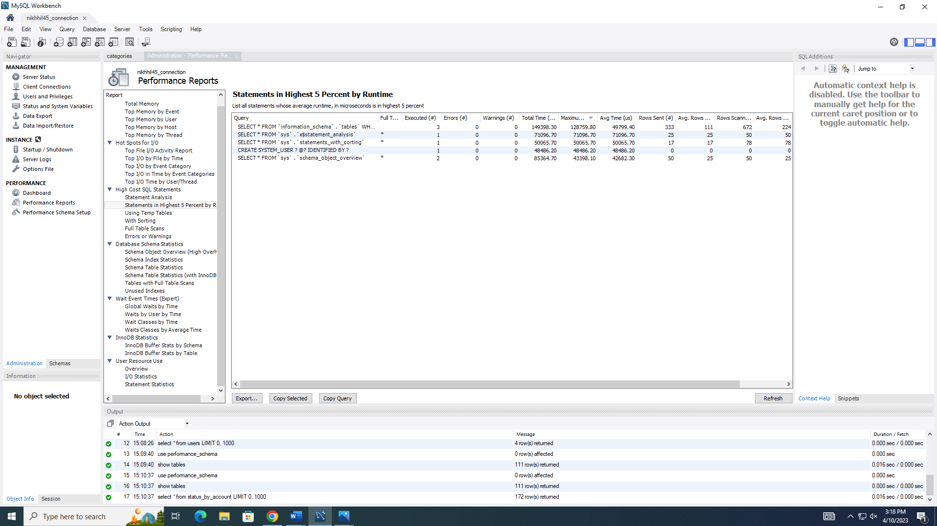

5) Using the Workbench Navigator panel, use the Performance Report area to determine the database statistic that shows the schema object overview high overhead for objects count; sort in ascending order (low to high) by count. Provide a screenshot to show your findings.
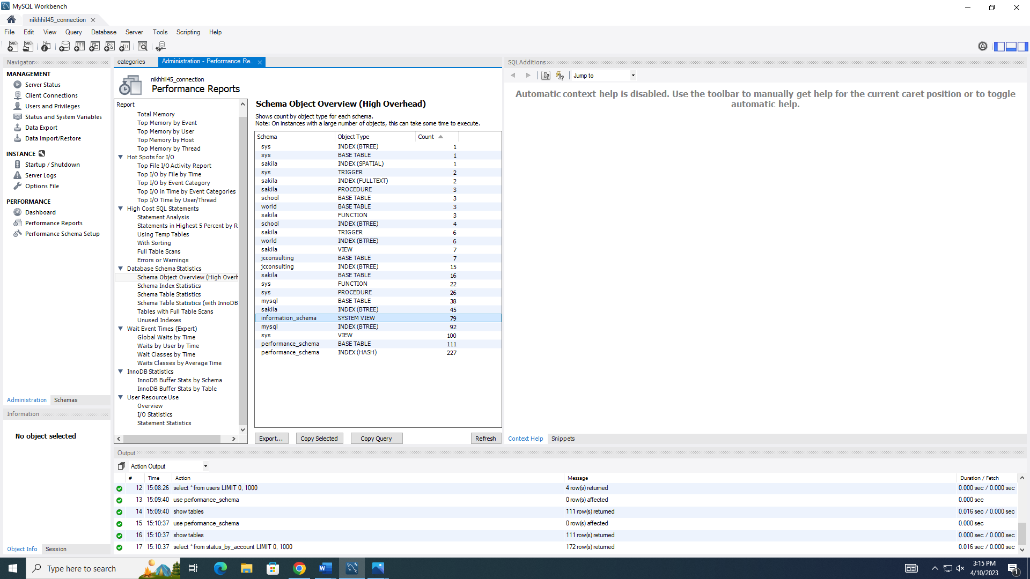

I have neither given or received, nor have I tolerated others' use of unauthorized aid.
- Nikhil Ramasani

